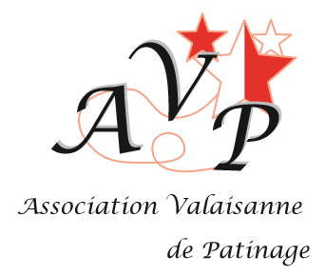
Champions Valaisans 2025-2026

Filière Performance
Juvenile U 14 Champéry Riesco Mélina

Juvenile U 14 garçons Champéry Poltorak Yakov

Adv. Nov. U 16 Champéry Marrone Alesya

Juniors Champéry Ezhova Valeryia

Seniors H Champéry Weiler Ean

Mixed Age Brig Reymond Elin

Filière Romande

Poussins Crans-Montana Profico Giulia

Benjamins Crans-Montana Bianchi Camilla
Avenirs Sion Siritsa Elena

Avenirs garçons Brig Zhu Oscar

Minimes Sion Biaggi Noémie

Filière Régionale

Acier B Monthey Turan Selin

Cuivre Sion Abreu Flavia

Inter-Bronze Champéry Grange Maxine

Bronze Champéry Russo Maria Sofia

